State of Florida

Agency for Workforce Innovation

One-Stop Management Information System
(OSMIS)

Software Requirement Specifications

Date: 30th November 2001
Version: 2.0

Prepared by:
Ajit Kanattil
Jennifer Grant
Michele Elliott
Rajan B. Pillai
Santosh Pradhan

Reviewed by: Approved by:
Sudhir Chanpuriya Rakesh Vahal

Document Change History
# | Date | Version No. | Description | By
1. | 10/31/2001 | 1.0 | 1st Version of the Document | Sudhir Chanpuriya
2. | 11/30/2001 | 2.0 | 2nd Version of the Document | Ajit Kanattil
Table of Contents

Document Change History 2
1. Introduction 7
1.1 Scope of the document 7
1.2 Organization of the document 8
1.3 Abbreviations and Descriptions 9
1.4 Notations and Descriptions 10
1.4.1 UML Symbols and Notations 10
1.4.1.1 Notations used inUse Case Diagrams 11
1.5 Reference Material 14
2. Overview 15
2.1 Key User Perspectives of OSMIS 17
2.1.1 Case Management Perspective 17
2.1.1.1 Activity Diagram – Case Management Perspective 18
2.1.1.2 Use Case Model - Case Management Perspective 19
2.1.2 Customer Perspective 20
2.1.2.1 Activity Diagram – Customer’s Perspective 21
2.1.2.2 Use Case Diagram - Customer’s Perspective 22
2.1.3 Employer Perspective 23
2.1.3.1 Activity Diagram – Employer’s Perspective 24
2.1.3.2 Use Case Diagram - Employer’s Perspective 25
2.1.4 Fiscal Perspective 26
2.1.4.1 Agency for Workforce Innovation (AWI) – Finance Management Perspective 27
2.1.4.1.1Financial Administrator Perspective 28
2.1.4.1.2Region Perspective 29
2.1.4.1.3System Clock Perspective 30
2.1.4.2 Use Case Diagram – Fiscal Perspective 31
2.2 Programs Covered in OSMIS 32
2.3 List of Users for OSMIS 39
3. Functional Requirements 40
4. Business Process Requirements 41
4.1 Case Management Perspective 42
4.2 Customer Perspective 50
4.3 Employer Perspective 52
4.4 Fiscal Perspective 53
5. INTERFACE REQUIREMENTS 56
6. Reporting Requirements 56
7. User Interface Requirements 56
7.1Site Map - OSMIS Prototype Version 2.0 57
7.1.1 One Stop 57
Correspondence 57
Download Template 57
7.1.2 Customer 57
7.1.3 Employer 58
7.1.4Fiscal 58
7.1.4.1FMTS Financial Administration 58
7.1.4.2FMTS Regions 59
7.1.4.3FMTS AWI 59
7.1.5 System Administration 60
8. Non–Functional Requirements 61
8.1 Technical Environment 61
8.1.1Production Environment Diagram 62
App Server 1 62
SUN F4800 62
8 Processors 62
App Server 2 62
SUN F4800 62
8 Processors 62
Development & Testing 62
Server 62
4 processors 62
SUN F6800 62
Storage 1.18 TB 62
T3E StorEdge 62
8.2 Availability 64
8.3 Performance 65
8.4 Scalability 65
8.5 Security 65
8.6 Data Conversion 66
8.7 Browser Compatibility 67
8.8 System Help and Error 67
8.8.1 Context Sensitive Help 67
8.8.2 Messages 67
8.9 Audit Trail 68
8.10 Multi-Lingual Aspects 68
Appendix A: OSMIS Functional requirements 70
Appendix b 1: Use CaseS – Case Management Perspective 70
Appendix b 2: Use CaseS – Customer Perspective 70
Appendix b 3: Use CaseS – Employer Perspective 70
Appendix b 4: Use CaseS – Fiscal Perspective 70
Appendix C: Glossary 70
Appendix D: List of system interfaces 70
appendix e: List of osmis reports 70
Appendix f: hardware Requirements 70
Appendix g: software configuration 70

1. Introduction

1.1 Scope of the document

The objective of this document is to present to AWI and OSMIS users the final version of requirement specifications which will form the basis for the application architecture and design. The requirement specifications have been finalized based on the JADS conducted subsequent to the submission of Software Requirement Specifications (SRS) Version 1.0. The review comments have been incorporated into the following sections of this document:

- Overview of Case Management perspective, Customer perspective, Employer perspective and Fiscal perspective [Sections 2.1.1, 2.1.2, 2.1.3, 2.1.4]

- Functional Requirements [Section 3 and Appendix A]

- Business Process Requirements [ Section 4, Appendix B1, Appendix B2, Appendix B3, Appendix B4]

- Interface Requirements [Section 5, Appendix D]

- Reporting Requirements [Section 6, Appendix E]

- User Interface Requirements [Section 7]

This document provides Gulf’s understanding of the functionality of the OSMIS application at three levels: Section 2 provides a high level view of the system, Section 3 provides a more detailed understanding of the functional requirements as given in the RFP and Section 4 presents a granular level description of the business rules and flows.

The OSMIS Application shall be developed in 2 stages (Year 1 and Year 2) as per the RFP. This document covers detailed functionality that shall be incorporated into Stage 1 only. Details of functionality to be covered in Stage 2 shall be provided then.

All further design and development of the OSMIS application will be progressed based on this analysis, after receiving approval on the SRS Version 2.0, from AWI.

1.2 Organization of the document

This document provides Gulf’s understanding of the functionality of the OSMIS application at three levels:

- Section 2 provides a high level view of the system

- Section 3 provides a more detailed understanding of the functional requirements, as given in the RFP

- Section 4 presents a granular level description of the business rules and flows.

Subsequent sections and each appendix attached to the SRS provide specific information regarding granular functionality, interfacing requirements, reporting requirements and other non – functional requirements.

1.3 Abbreviations and Descriptions

Abbreviation | Description
AMSFW | Adult Migrant and Seasonal Farm Workers
AWI | Agency for Workforce Innovation
DCF | Department of Children and Families
DOA | Department of Agriculture
DOL | Department of Labor
DVOP | Disabled Veteran’s Outreach Program
EBT | Electronic Benefits Transfer
ENDS | Enhance Nation Data System
ERP | Eligibility Review Program
FLAIR | Florida Accounting Information Resource
FLUID | Florida Unemployment Insurance Database
FLORIDA | Florida On-line Recipient Integrated Data Access
FMTS | Financial Management Tracking System
FSET (P) | Food Stamp Employment and Training (Program)
Gulf/GULF | Gulf Computers, Inc.
HTML | Hyper Text Markup Language
IRP | Individual Responsibility Plan
ITA | Individual Training Account
JAD/JADS | Joint Application Development
JIS | Jobs Information System
JPR | Job Participation Rate
LVER | Local Veteran’s Employment Representatives
MIP | Micro Information Product
MIPS | Management Information and Payment System
MIS | Management Information System
NFA | Notice of Funds Availability
NOO | Notice of Obligation
ODDS | Online Data Display System
OSMIS | One-Stop Management Information System
OSST | One-Stop Service Tracking
PEAR | Participant Expense Authorization Request
RFP | Request For Proposal
RITA | Retention Incentive Training Accounts
RWB | Regional Workforce Board
SCEP | Senior Community Employment Program
SSI/SSDI | Supplemental Security Income/Social Security Disability Income.
TANF | Temporary Aid to Needy Families
TCA | Temporary Cash Assistance
UC | Unemployment Compensation
UI | Unemployment Insurance
UML | Unified Modeling Language
USA | United States of America
VETS | Veteran’s Program
WFI | Workforce Florida, Inc.
WIA | Workforce Investment Act
WOTC | Work Opportunity Tax Credit
WTP | Welfare Transition Program

1.4 Notations and Descriptions

The methodology for this presentation employs a structured format conforming to the UML guidelines for each perspective.

1.4.1 UML Symbols and Notations

Use Cases are a way to describe and present business functions from a user perspective. All requirements for a user to accomplish a particular task are gathered together in a single Use Case. The Use Case model is a collection of all individual Use Cases.

Advantages of Use Case modeling include:

- Facilitates communication among Project Teams

- Assures Architectural soundness

- Provides a visual modeling language for building an object-oriented and component based system

- Provides users with a ready-to-use, expressive visual modeling language, providing the ability to develop and exchange meaningful models

- Provides independence from programming languages and development processes

- Provides stakeholders the ability to development organization to work as one team with one language and one tool, by using UML to visualize, specify, construct, and document the artifacts of the system

- Supports High Level Development concepts such as components, collaborations, frameworks and patterns

Use Case modeling consists of diagrams that give a visual overview of the system, followed by text that describes the actors and the Use Cases.

1.4.1.1 Notations used inUse Case Diagrams

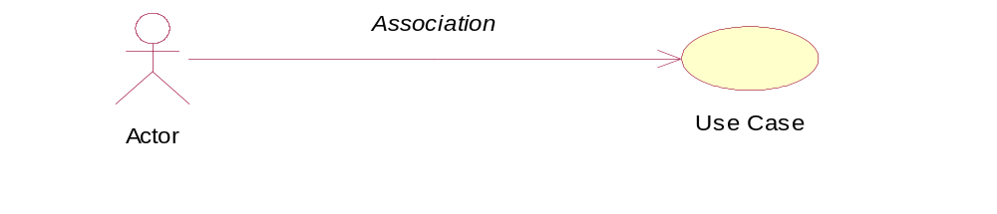

Actor: An actor represents anything that interacts with the sytem. A Use Case describes a sequence of interactions, between actors and the system, which occur when an actor uses the system.

Communicates-Association: A line is used to represent a channel of communication between an actor and a Use Case. Relationships between actors and Use Cases are called communicates-associations.

Use Case: A Use Case describes a “complete” flow through the system until the resulting value is achieved for the associated actor(s). A Use Case contains the following information.

- Descriptions of actions the system takes inorder to deliver something of value to the actor

- Descriptions of the system functionality used by the actor

- Models, showing dialog between the system and actors

- Provides a complete and meaningful flow of events from the perspective of a particular actor

Use Case Specifications: The Use Case specification describes the details of a particular Use Case and typically comprises the following:

Sr. | Section Name | Description
1. | Use Case Id | <first three letters for the perspective>_(max. seven letters for the abbreviation of Use Case Name>_Ver (in the format #.#)
2. | Use Case Name | Name of the Use Case
3. | Module | The perspective where the Use Case belongs (Customer, One-Stop, Employer or Fiscal)
4. | Functional Requirement ID | The IDs of the Functional Requirements that are fulfilled by the Use Case
5. | Prepared By | Person prepared the Use Case
6. | Date | Date Use Case was prepared
7. | Reviewed By | Person who reviewed the Use Case
8. | Date | Date Use Case was reviewed
9. | Approved By | Person who approved the Use Case
10. | Date | Date Use Case was approved
Revision History
11. | Date | Date of Revision
12. | Version | Version name
13. | Change Description | Description of changes made to the Use Case
14. | Author | Person who made the changes
Use Case
15. | Use Case Name | Name of Use Case
16. | Brief Description | Description conveying the role and purpose of the Use Case
17. | Actors | External person, process, time or thing interacting with the system
18. | Primary Actor | Actor who initiates the Use Case
19. | Secondary Actor | Actor who is affected by the Use Case
20. | Use Case Model Diagram | Diagram that shows the interaction between Actor(s) and Use Case(s)
21. | Pre-condition | State of the system, that must be present, prior to a Use Case being performed
Flow of Events
22. | Basic Flow | What the actor does and what the system does in response
23. | Alternate Flow | Descriptions of more complex alternatives
24. | Special Requirements | Typically a nonfunctional requirement that is specific to a Use Case, but it is not easily or naturally specified in the text of the Use Case’s event flow
25. | Post-condition | List of possible states the system can be in immediately after a Use Case has finished
26. | Extension Points | Description of additional behaviors of the Use Case
27. | Relationships | Description of the relationships between Use Case Model elements
28. | Assumptions | Various assumptions made while defining the Use Case

1.5 Reference Material

The following documents have been referred to for the preparation of this document.

- Request For Proposal (AWI 0003-01/RH-RFP)

- Contract (document between Gulf and AWI)

- Clarifying Information for Vendors

- JAD session comments and subsequent review documents

- Documentation of existing information systems under production

2. Overview

The OSMIS Application is a One-Stop Integrated Web based system, which shall have all the functionality outlined by the following objectives in the RFP:

Integrate Case Management for Workforce Investment Act and Welfare Transition programs

- Replace the ODDS/ENDS/JIS Systems

- Replace the FMTS and Augment the Functionality Including EBT

- Develop a Common Customer Intake System

- Develop an Electronic Interface Between the Consolidated Case Management System and UC

- Develop a Robust Decision Support/MIS/Reporting Facility

- Other Information Technology Facilities

As can be seen, the proposed OSMIS system will not only replace some of the existing systems, but will also provide enhanced functionality such as Common Customer Intake, Decision Support System etc., not existing in any of the systems being replaced. Further, as per the requirement of the RFP, all functionality of the existing One-Stop Service Tracking (OSST) system will be integrated into the main application to make the entire application function as an Integrated One-Stop Management Information System.

This section attempts to communicate Gulf’s perception of how the proposed OSMIS system is required to provide the above functionality in an integrated fashion and how it will interact with the users. As already pointed out, OSMIS will be a single integrated system, replacing the existing disparate systems, while providing additional new functionality. A description of functionality given above, if attempted strictly in order of objectives, will fail to communicate the proposed OSMIS system as an integrated whole. Therefore, this section gives an overview of the functionality provided in OSMIS via key users’ “perspectives”. Each perspective basically describes users’ interaction with the system from a specific point of view.

To maintain focus on a holistic perception of the proposed system, this section limits itself to a high-level view of the proposed OSMIS system [Detailed views are presented in the subsequent sections]. The above-mentioned view is communicated as follows:

- A diagrammatic representation from the point of view of various users of the proposed system (ref. Section 2.1)

- A list of programs covered by OSMIS (ref. Section 2.2)

- A list of users who will interact with OSMIS (ref. Section 2.3)

2.1 Key User Perspectives of OSMIS

This section intends to communicate, diagrammatically, a high level view of the functionality to be provided by OSMIS. To this end, the proposed functionality is described here in terms of the “perspectives.” Each perspective describes the users’ interaction with the system from a specific user viewpoint (e.g. case management, customer, employer, fiscal personnel).

The methodology for this presentation employs a structured format conforming to the UML guidelines (Use Case model and activity diagrams) for each perspective. Broadly speaking, a Use Case model depicts the static aspects of the system while the activity diagram illustrates the process flows of the system.

2.1.1 Case Management Perspective

This perspective intends to communicate how OSMIS shall automate the various aspects of management and administration of cases relating to program beneficiaries. The scope of this perspective begins with the applicant being registered under a program and ends when the applicant transitions out, as a self-sufficient/employed individual. This perspective also covers a participant’s view since, after a point, he/she operates through the Case Manager.

The Case Management aspect of the system is represented below, diagrammatically, with the help of the following:

- Activity Diagram – Case Management Perspective

- Use Case Model – Case Management Perspective

2.1.1.1 Activity Diagram – Case Management Perspective
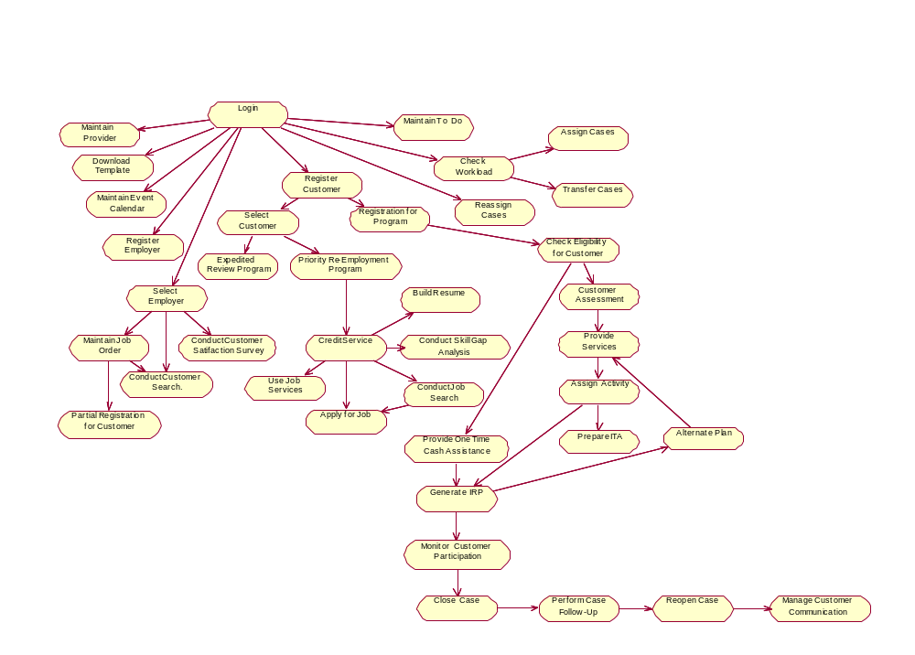

2.1.1.2 Use Case Model - Case Management Perspective
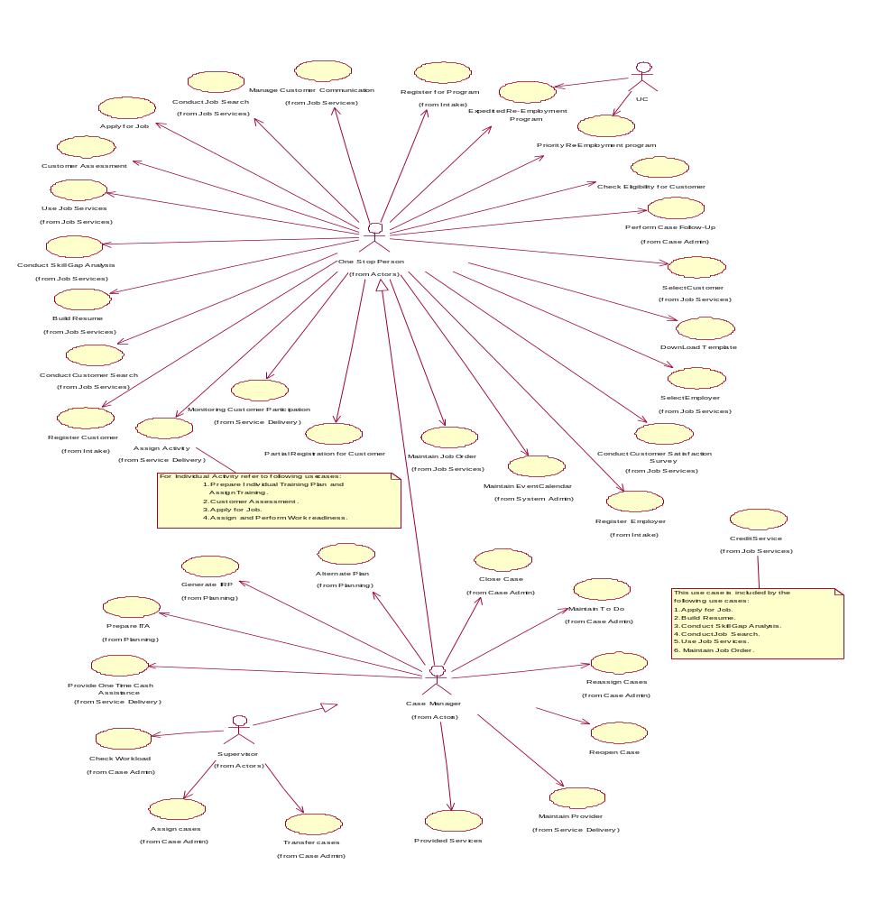

2.1.2 Customer Perspective

This perspective intends to communicate how OSMIS will be perceived by and interact with a customer. A customer, in this context, is defined as a person who, subsequent to registration as a user of OSMIS, can have access to some services offered by the One-Stop agencies such as Job Search, Resume Building, and Access Labor Market Information. The customer could avail these services directly or seek the assistance of One-Stop staff, if required. The customer, in the context of the current definition, is not a beneficiary of any welfare or workforce oriented programs currently being addressed by OSMIS.

A customer’s interaction with the system is represented below, diagrammatically, with the help of the following:

- Activity Diagram - Customer Perspective

- Use Case Model - Customer Perspective

2.1.2.1 Activity Diagram – Customer’s Perspective
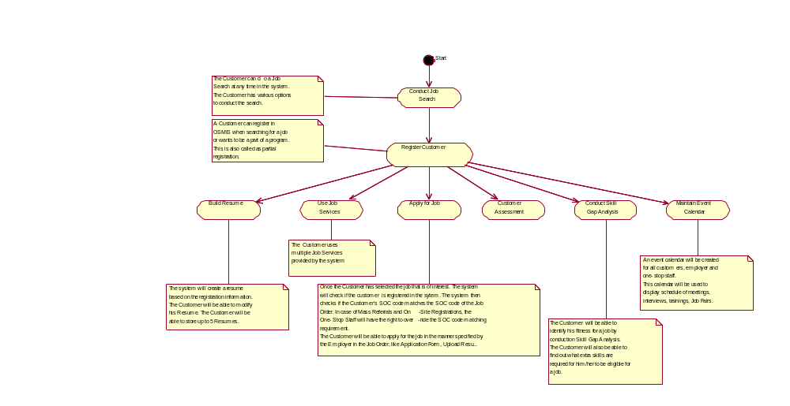

2.1.2.2 Use Case Diagram - Customer’s Perspective
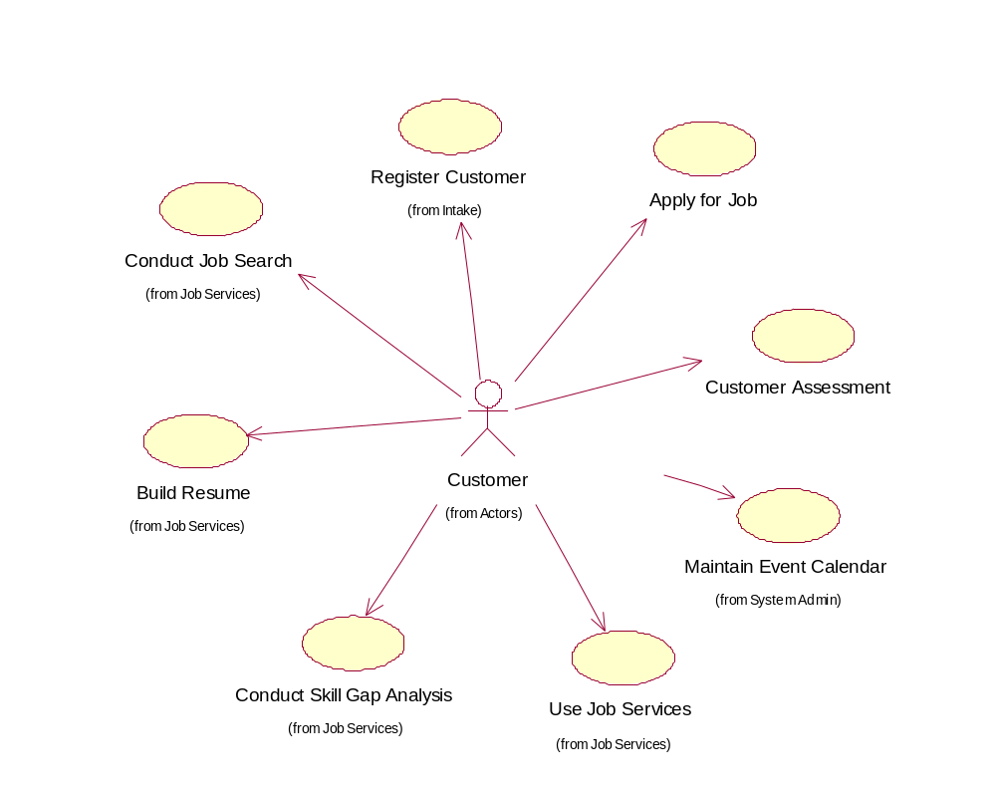

2.1.3 Employer Perspective

This perspective intends to communicate how OSMIS will be perceived by and interact with an employer. An employer will have access to features such as maintaining job orders, maintaining event calendars, conducting searches for prospective employees etc.

An employer’s interaction with the system is represented below, diagrammatically, with the help of the following:

- Activity Diagram - Employer Perspective

- Use Case Model - Employer Perspective

2.1.3.1 Activity Diagram – Employer’s Perspective
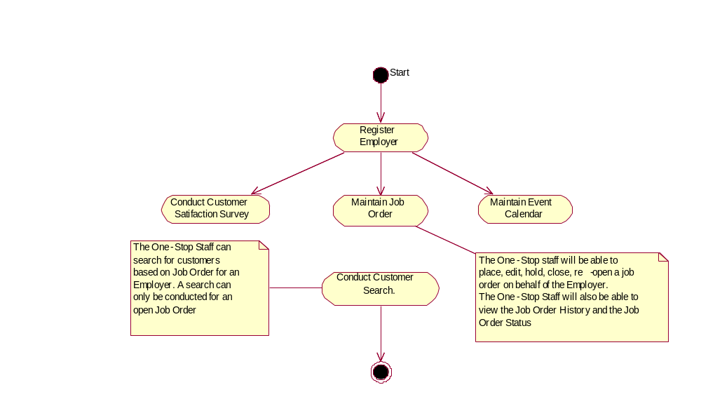

2.1.3.2 Use Case Diagram - Employer’s Perspective
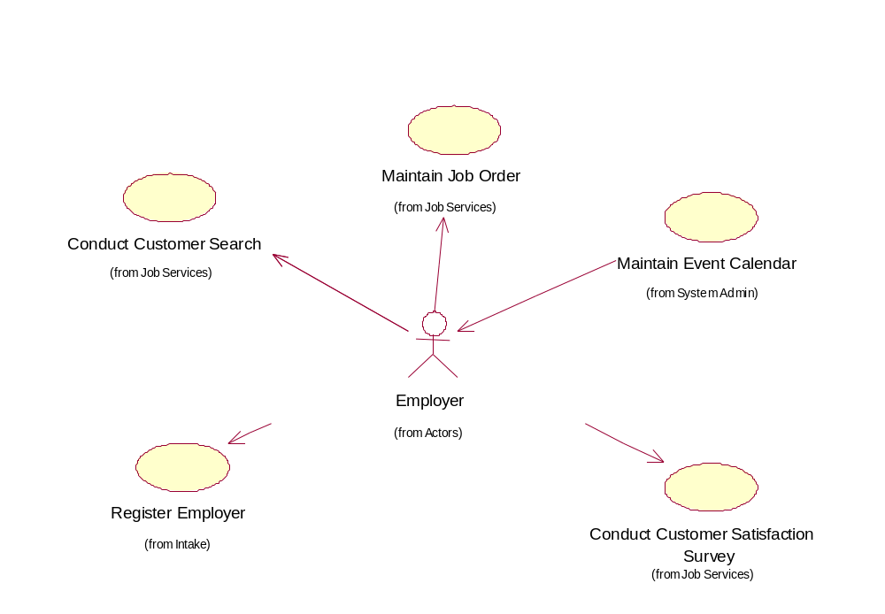

2.1.4 Fiscal Perspective

This perspective intends to communicate how OSMIS will maintain information related to tracking inflow of funds to AWI, disbursement of funds towards various programs and generating financial management reports.

These aspects of the system are represented below, diagrammatically, with the help of the following:

- Activity Diagram – Fiscal Perspective

- Use Case Model – Fiscal Perspective

2.1.4.1 Agency for Workforce Innovation (AWI) – Finance Management Perspective
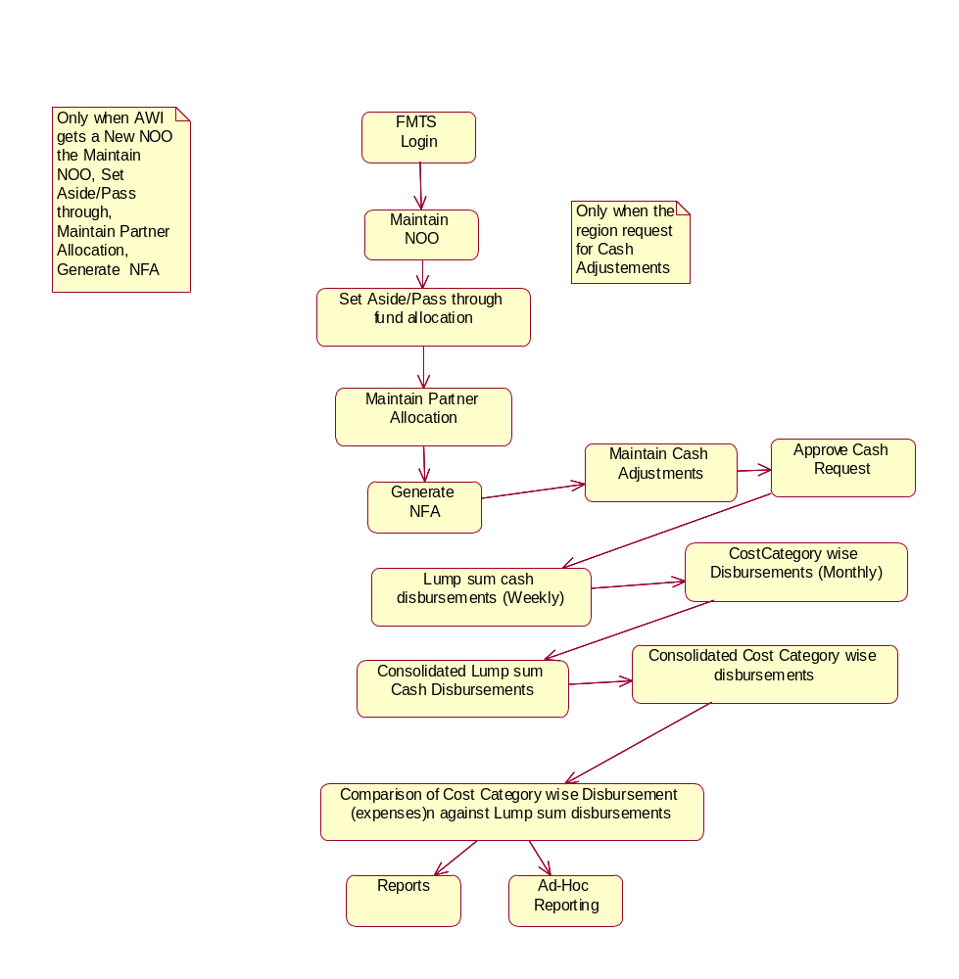

Financial Administrator Perspective
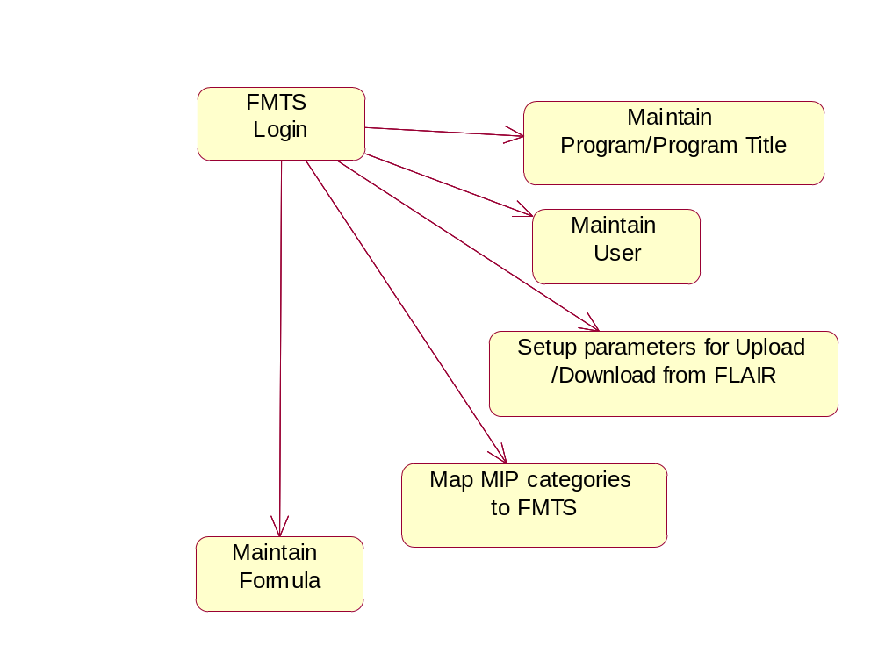

Region Perspective
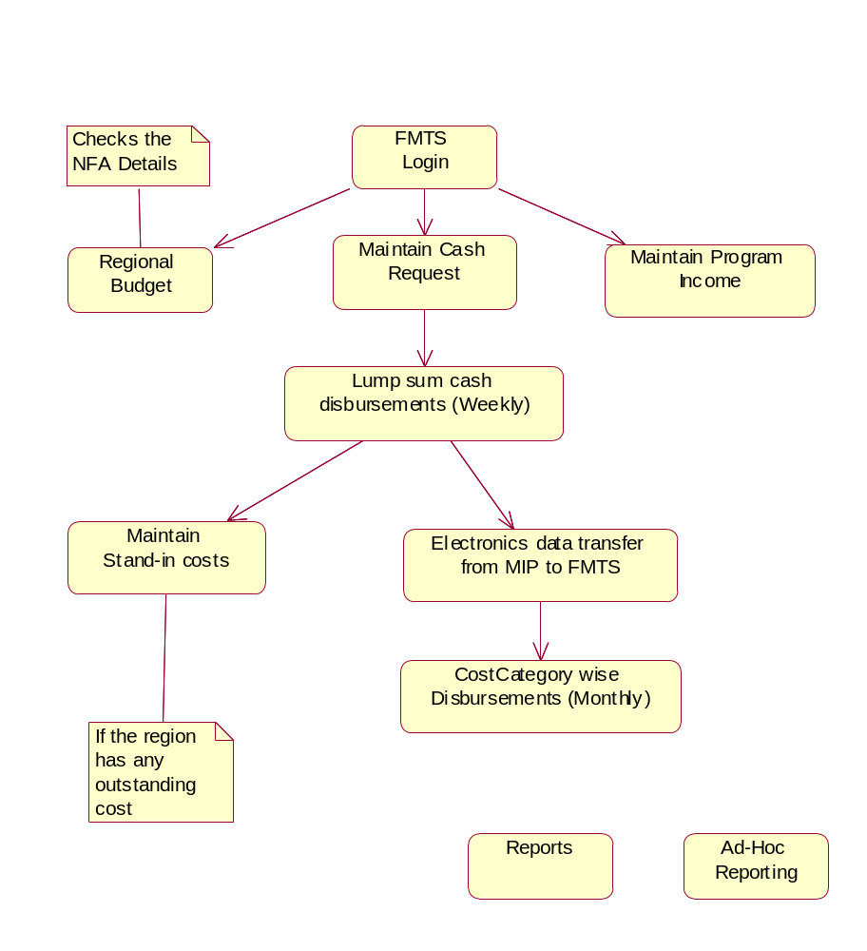

System Clock Perspective
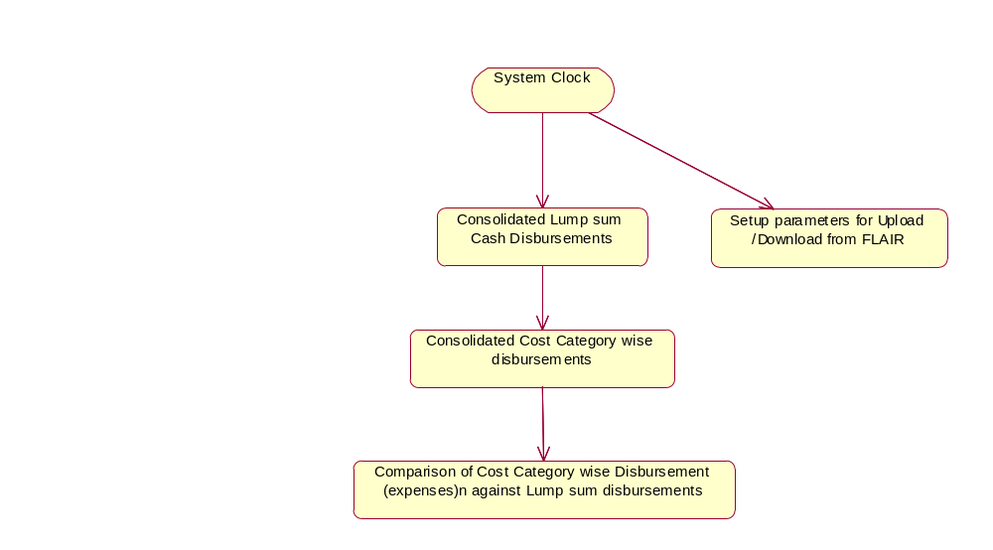

2.1.4.2 Use Case Diagram – Fiscal Perspective
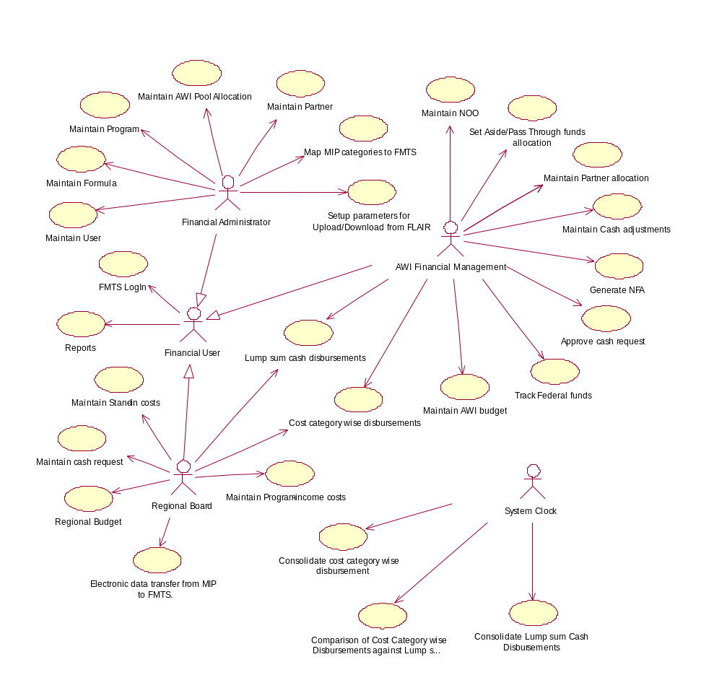

2.2 Programs Covered in OSMIS

In the course of the study of the RFP followed by detailed JAD sessions and meetings with key stakeholders, it was decided to incorporate the functionality related to the programs listed below, as per the priority specified by AWI/WFI. This prioritization will aid in the determination of the sequence in which the various processes of the OSMIS project will be implemented. The following table represents this information:

# | Programs | Brief Description | Stage | Remarks
1 | Workforce Investment Act (WIA) | The Workforce Investment Act (WIA) of 1998 provides the framework for a unique national workforce preparation and employment system designed to meet both the needs of the nation’s businesses and the needs of job seekers and those who want to further their careers. WIA specifies three funding streams to the states and local areas:  - Adults  - Dislocated Worker  - Youth | Stage 1 | High Priority
2 | Welfare Transition Program (TANF) | In Florida, the TANF work program is called the Welfare Transition program. The goal of the Welfare Transition Program is to emphasize work, self-sufficiency, and personal responsibility. | Stage1 | High Priority
3 | Welfare to Work (WtW) | The purpose of the Welfare-to-Work Program is to create job opportunities for those “hardest-to-employ” by providing job placement services and transitional employment services. Welfare to Work is supported with two types of grants:  - Formula grants aim to expand the capacity and capability of local systems to place eligible recipients into jobs.  - Competitive grants aim to find new ways to help the hardest to employ, make the transition to work and to target resources in areas of high need. The WtW program serves mainly as a funding source. | Stage1 | High Priority
4 | Wagner-Peyser (WP) | Wagner- Peyser is a federally funded labor exchange program that serves the following purposes:  - Changes in employment service planning  - Coordination and funding related to amendments to the Wagner-Peyser Act  - Individuals seeking employment  - Employers seeking workers  - It also serves as a reporting facility for employer and customer performance. | Stage 1 | High Priority
5 | Food Stamp, Employment and Training (FSET) | The Food Stamp Employment and Training Program, often referred to as FSET, is funded annually through a grant provided to the Department of Children and Families, by the United States Department of Agriculture, Food and Consumer Service, along with general revenue funds appropriated by the Florida Legislature. The goal of the FSET program is to emphasize work, self-sufficiency, and personal responsibility. | Stage 1 | High Priority
6 | Veterans’ Program (VETS) | The Agency for Workforce Innovation (AWI) Veterans' Program involves the provision of priority workforce services to veteran customers in the One-Stop career centers around the State. | Stage 1 | High Priority
7 | Retention Incentive Training Account (RITA) | Broadly speaking, RITA intends to promote job retention and to enable upward job advancement into higher skilled and higher paying employment. | Stage 1
8 | Teen Parent and Pregnancy Prevention Diversion | The purpose of the Teen Parent and Pregnancy Prevention Diversion Program is to provide services to reduce and avoid welfare dependency by:  - Reducing teen pregnancy  - Reducing the incidence of multiple pregnancies to teens  - Assisting teens in completing educational programs | Stage 1
9 | Senior Community Employment Program (SCEP) | The Senior Community Employment Program, funded under Title V of the Older Americans Act, serves persons:  - With low incomes  - Who are 55 years old or over  - Who have poor employment prospects | Stage 1
10 | Unemployment Compensation (Interface) | In the context of OSMIS, this refers to an interface to be built with the Unemployment Compensation System (UC) which will provide the following:  - A batch file of candidates profiled will be sent to the UC System  - A batch file of candidates whose ERP have been completed will be sent to the UC System  - Link to the FLUID, On line registration for Unemployment compensation | Stage 1
11 | Adult Education | Funded by the Workforce Investment Act, Adult Education promotes:  - Basic and functional literacy  - Help with academic and learning skills to obtain or maintain employment  The objective is achieved by offering General Education Programs and courses such as:  - Adult Basic Education  - Adult Secondary Education  - Adult High School Credit  - GED preparation/test | Stage 2
12 | Vocational Rehabilitation | Vocational Rehabilitation, a state-supported division of services, assists individuals with disabilities who are pursuing meaningful careers. Vocational Rehabilitation assists those individuals in securing gainful employment commensurate with their abilities and capabilities through local job searches and awareness of self-employment and telecommuting opportunities. | Stage 2
13 | Adult Migrant and Seasonal Farm Worker (AMSFW) | The Adult Migrant and Seasonal Farm Worker Training and Employment Program addresses chronic unemployment and underemployment experienced by workers in the agricultural industry. | Stage 2
14 | Transitional Readjustment Assistance (TRA/TAA) | The North American Free Trade Agreement (NAFTA) Transitional Readjustment Assistance Program (NAFTA-TAA) assists workers who are  - Laid off  - Forced to work part-time as a direct result of increased imports from Mexico and Canada or of a shift of U.S. production to those countries  - Threatened with job loss or reduced work hours for those reasons. | Stage 2
15 | Work Opportunity Tax Credit (WOTC) | The Work Opportunity Tax Credit (WOTC) is a federal income tax credit that encourages private sector employers to hire eight targeted groups of job seekers. The tax incentive is designed to help job seekers, most in need of employment opportunities, by allowing them to gain On-The-Job Experience, thereby helping them move toward economic self-sufficiency. | Stage 2
16 | Job Corps | The Job Corps Program helps economically disadvantaged young adults by providing them with opportunities to develop the vocational, educational, and social skills needed to succeed. | Stage 2

2.3 List of Users for OSMIS

This section names and describes the various users of OSMIS.

In the UML, users of the system are represented as Actors.

# | User | Description
1 | Customer | Customers are recipients of services.  In OSMIS, Customers are “Universal Customers” and are not beneficiaries of any welfare/workforce related programs.
2 | Participant | Participants are recipients of services and beneficiaries of one or more workforce/welfare related programs.  These Participants are also known by their current status of:  - “Applicants”  - “Mandatory”  - “Transitional”
3 | One-Stop Person | One-Stop Person is any person in a One-Stop Center. Specific roles are identified in OSMIS as follows:  - Security Officer: A One-Stop Person who does system administration; this person assigns users specific roles and responsibilities.  - Supervisor: A One-Stop Person who monitors the performance and work allocation of to the Case Managers.  - Case Manager: A One-Stop Person who will be handling a customer’s case across all program/s.  - Program Manager: A One-Stop Person who will help the customer with specific program/s.  - Job Developer: A Job Developers is a person who will help customer to conduct Job Search. This is an Assisted Job Search service.
4 | Employer | Employer is a prospective employer in search of customers (or participants) to hire.
5 | State Person  Financial User | State Person is a person from any state agency who will use OSMIS for their work.  Financial User is a person who will use the financial module of the OSMIS system.

3. Functional Requirements

This section intends to provide a more detailed description of Gulf’s understanding of the functional requirements to be covered by the OSMIS system as specified in the RFP. The requirements stated in the RFP have been revisited here in greater detail and precision.

The functional requirements are presented in the order of Objectives, as given in the RFP.

Obj. # | Objective | Reference
1 | Integrate Case Management for Workforce Investment Act and Welfare Transition programs. | Appendix A – Section 1
2 | Replace the ODDS/ENDS/JIS system. | Appendix A – Section 2,  Section 4
3 | Replace the FMTS and Augment the Functionality Including EBT. | Appendix A – Section 3
4 | Develop a Common Customer Intake System | Appendix A – Section 4
5 | Develop an Electronic Interface Between the Consolidated Case Management System and UC. | SRS - Section 5
6 | Develop a Robust Decision Support/MIS/Reporting Facility | SRS - Section 6
7 | Other Information Technology Facilities | SRS - Section 8

4. Business Process Requirements

This section details Gulf’s understanding of the functionality required to be incorporated into OSMIS. To this end, this section provides the business processes and rules at a more granular level using the Use Case Specifications. Each perspective described in section 2.1 is employed as the starting point. Detailed functionality involved in each perspective is listed here with the help of Use Cases. These details present the business rules and the flow of events related to the Use Case in a structured format conforming to the UML conventions (reference section 1.3).

4.1 Case Management Perspective

The detailed understanding of this perspective is contained in the following Use Cases.

# | Use Case Name | Brief Description | Reference
1 | Register Customer | The objective of this Use Case is to allow a customer to register to the system. | Appendix B2 – Sr. 1.
2 | Partial Registration for Customer | The objective of this Use Case is to allow a one-stop staff to partially register a customer into the system. | Appendix B2 – Sr. 2.
3 | Select Customer | The use case takes place when the Case Manager needs to open a case. Opening a case is nothing but selecting it. A case needs to be opened before working on it. There are two ways this use case takes place, either the Case Manager can click on the “case name” from its caseload list or the Case Manager can jump to a case by entering the social security number. This Use Case also describes the process in which a One-Stop Staff is able to retrieve details of one specific Customer to perform job-service functions related to that Customer. The One-Stop Staff gets this information by entering the Customer’s Social Security Number. | Appendix B1 – Sr. 1.
4 | Check Eligibility for Customer | This use case starts when the customer wants the available services of a particular program – one stop partner. The customer has to prove his eligibility before being provided services by a program. The purpose of this use case is to determine eligibility of the customer, who wants to participate in a program. Customer and the one stop staff representative play a role in this use case. | Appendix B1 – Sr. 2.
5 | Register for Program | The objective of this Use Case is to allow a case manager to register a customer for a program. | Appendix B2 – Sr. 3.
6 | Use Job Services | This Use Case describes the process by which a Customer can access various Job Services sites and record the information in his profile. | Appendix B2 – Sr. 4.
7 | Conduct Job Search | This Use Case will describe the process in which a customer will conduct a Job Search. The customer will be able to search for jobs anywhere in USA or any region in Florida. The customer will also be able to search for Jobs by Company, Job Category or Zip code. The customer will also be able to conduct an advanced search where he can select multiple search parameters. The One-Stop person will also be able to conduct an assisted job search for an applicant. | Appendix B2 – Sr. 5.
8 | Apply for Job | This Use Case shall describe the process in which Customer can apply for a posted job. The Use Case also describes the process of Mass Referrals. | Appendix B2 – Sr. 6.
9 | Build Resume | This Use Case describes the process by which a Customer can build and manage his/her Resume. | Appendix B2 – Sr. 7.
10 | Conduct Skill Gap Analysis | This Use Case describes how Skill Gap analysis for a Customer is done. | Appendix B2 – Sr. 8.
11 | Credit Services | This Use Case describes the process of crediting a rendered service to the One-Stop Staff or the One Stop for the activities. | Appendix B3 – Sr. 6.
12 | Conduct Customer Search | This Use Case will describe the process of searching for Customer. An Employer will be able to conduct a search for Customer based on any Job Orders with an open status. The One-Stop Staff will be able to conduct a search for a Customer based on various parameters. | Appendix B3 – Sr. 3.
13 | Conduct Customer Satisfaction Survey | This Use Case describes the process of conducting the Customer Satisfaction Survey. | Appendix B3 – Sr. 4.
14 | Manage Customer Communication | This Use Case describes the process of maintaining record of communication with the Employer. The Use Case also describes the process of mail merge for Customers and Employers. | Appendix B1 – Sr. 5.
15 | Customer Assessment | The Customer seeking to further his or her skills for work-readiness will perform the assessment with either the One-stop Center or a contracted Vendor. The purpose of this use case is to depict the assessment, which the customer takes. The customer, one stop staff representative, and the vendor play a role in this use case. | Appendix B1 – Sr. 3
16 | Generate IRP | This Use Case is used to build the Individual Responsibility Plan (IRP) for the participant. | Appendix B1 – Sr. 6.
17 | Alternative Plan | This Use Case occurs when the Case Manager needs to prepare an Alternate Plan for a participant (also called recipient). This Use Case describes various conditions under which Alternate Plan is prepared; these are Hardships, Deferrals, Substance Abuse Mental Health, Sanctions (Level I/II/III) and SSI/SSDI. Sometimes the Customer may be facing challenges, which may require the Case Manager to prepare an Alternate Plan. | Appendix B1 – Sr. 7.
18 | Assign Activity | This process describes assigning an activity for a participant and capturing the details for the activity. Activities are as follows:  - Prepare Individual Training Plan and Assign Training.  - Customer Assessment.  - Apply for Job.  - Assign and Perform Work readiness.  Please refer to respective Use Cases for above-mentioned activities. | Appendix B1 – Sr.8.
19 | Prepare ITA | Individual training accounts (ITA) must be expended on programs that prepare people to enter high-wage occupations Workforce Estimating Conference (previously called Workforce Estimating Occupational Forecasting Conference) and on other programs as approved by Workforce Florida Inc. For each approved training program, the regional workforce boards, in consultation with training providers, shall establish a fair-market purchase price to be paid through an Individual Training Account. The Customer Expense Authorization Request (PEAR) is a form that projects allocated cost for support services and training per program year. This is supplementary form often accompanies the ITA when requesting program funds. This use case details the preparation of ITA. The case manager, customer, supervisor and the accountant play a role in this use case. | Appendix B1 – Sr. 9.
20 | Provide Services | This use case takes care of providing the services required for the participants. These services are provided by the Service Providers designated by the Regional Workforce Board for the One Stop Center. | Appendix B1 – Sr.10.
21 | Provide One Time Cash Assistance | This Use Case covers the one time cash assistance given to the participant to save the Temporary Cash Assistance (TCA) given. As TCA is a time limited program. Benefits for families headed by eligible adults, are limited to  24 months in a 60 month period or  36 months in a 72 month period for some families who have been on assistance a long time or have limited job skills and education.  There is a lifetime time limit of 48 months. | Appendix B1 – Sr. 11.
22 | Monitor Customer Participation | Monitoring Customer Participation is a process wherein the case manager keeps track of the participant’s progress during the various activities. There is a report Job Participation Rate that keeps track of the customer’s participation rate. The requirement of JPR is the customer should participate in the assigned activities for 30 hrs a week. | Appendix B1 – Sr. 12.
23 | Check Workload | This Use Case takes place when the Supervisor needs to view list of case managers in his/her unit and also the number of cases managed (either open or closed, called “caseload”) by respective case managers. The Supervisor can select any Case Manager’s caseloads to view associated cases. If the supervisor also carries a caseload, his/her name is listed as a case manager. | Appendix B1 – Sr.13 .
24 | Maintain ‘To Do’ List | The To Do List is the supervisor and case manager alert. You also have the option of creating tasks as personal reminders or tasks for other users of the system. | Appendix B1 – Sr.14 .
25 | Assign Cases | The use case takes place when a supervisor needs to assign cases to its case managers within a unit. Everyday supervisor receives new cases from FLORIDA system. These cases need to be assigned to case managers to follow up with the customers. Only those cases belonging to WTP and FSET programs are assigned in this used case. | Appendix B1 – Sr.15 .
26 | Reassign Cases | The use case takes place when the Case Manager needs to assign a case to another case manager within a unit. The Case Manager can reassign open as well as closed cases. | Appendix B1 – Sr.16 .
27 | Transfer Cases | The use case takes place when supervisor shall send a case to a different region. Relocation is one of the reasons why a case shall be transferred to a different unit. Only closed cases can be transferred out of a unit. A transferred case is sent to a virtual case manager (e.g. Assignment, Unit: 400). The supervisor can assign these cases from the caseload of above mentioned “unit assignment” to its case manager. This transfer shall take place for Welfare Transition type of cases. | Appendix B1 – Sr.17 .
28 | Close Case | The participant after becoming self-sufficient the case is closed. This Use Case describes how to close a case and the various conditions under which the case cannot be closed. | Appendix B1 – Sr.18 .
29 | Perform Case Follow Up | The case manager does a follow up of the customer for whom the job placement was made for up to 1 year. These follow ups are recorded for future reference. | Appendix B1 – Sr.19 .
30 | Reopen Case | The use case takes place when the Case Manager needs to open a “closed” status on a case, related to a program. OSMIS shall allow a customer to participate in one or more programs. Customer shall have one case but its status in different programs shall be tracked using a tracking field, “Program Status”, tied to that case. In context with the WIA program, a new case is opened even if the customer is a “returning” customer. So, “Reopen Case” doesn’t apply to WIA. But a WTP program uses the same case for providing the benefits to the customer. When the customer first registers with WTP, its status is “Applicant” or “Mandatory” (if the case is received from FLORIDA). “Applicant” case changes its phase to “Mandatory” if approved eligible by DCF. After the case is closed from FLORIDA system, one-stop can reopen it to continue providing benefits to the customer. So, the system shall maintain independent status (“Program Status”) for each program. These are open and close. Sometimes cases are transferred to different units and need to be opened in that particular unit. If a case is opened for a program, customer needs to prove the eligibility to get benefits from the respective program. Case could be closed due to following reasons. These are,  FLORIDA sanctions in WTP program  Successful exit from WTP program where DCF stopped benefits to the customer.  Self-sufficiency through a program. | Appendix B1 – Sr.20.
31 | Maintain Provider | This Use Case takes place when the Case Manager needs to keep information of the providers (Employment, Service, Training). One Stop contracts with the providers to provide employment, training, services which are then offered to the customers of a program like (WIA, WTP and FSET). | Appendix B1 – Sr.21.
32 | Maintain Event Calendar | This Use Case describes the process in which all relevant events are maintained in a public calendar. This calendar will be available for all Customers, Employer and One-Stop Staff. The RWB staff will have access to the calendars of all one-stops under them. The calendar will be used to schedule activities, meetings and Job Fairs. | Appendix B1 – Sr.22.
33 | Maintain Job Order | This Use Case will describe the process in which an employer can create and manage Job Order. The Employer or One Stop Staff can place, edit, clone, hold, close and re-open job order. The Employer/ One Stop Staff can view the Job Order History and the status of each Job Order. | Appendix B1 – Sr.23 .
34. | Download Template | The Use Case describes the process in which a One-Stop Staff is able to maintain a library of templates. This library will contain the printable formats of all forms in the system. | Appendix B1 – Sr.24.

4.2 Customer Perspective

The detailed understanding of this perspective is contained in the following Use Cases.

# | Use Case Name | Brief Description | Reference
 | Register Customer | The objective of this use case is to allow a customer to register to the system. A Customer can register online or a One Stop Staff can register the customer | Appendix B2 – Sr. 1.
 | Use Job Services | This Use Case describes the process by which a Customer can access various Job Services sites and record the information in his profile. | Appendix B2 – Sr. 4.
 | Conduct Job Search | This Use Case will describe the process in which a customer will conduct a Job Search. The One-Stop person will also be able to conduct an assisted job search for an applicant. The Customer will have a option to do a General Job Search or Advanced Job Search | Appendix B2 – Sr. 5.
 | Apply for Job | This Use Case shall describe the process in which Customer can apply for a posted job. | Appendix B2 – Sr. 6.
 | Build Resume | This Use Case describes the process by which a Customer can build and manage his/her Resume. The Customer also has the ability to View and Edit his Resume. On creation of every new Resume, a rendered service is credited to the One-Stop or the One-Stop Staff. | Appendix B2 – Sr. 7
 | Conduct Skill Gap Analysis | This Use Case describes how Skill Gap analysis for a Customer is done. | Appendix B2 – Sr. 8.
 | Maintain Event Calendar | This Use Case describes the process in which all relevant events are maintained in a public calendar. This calendar will be available for all Customers, Employer and One-Stop Staff. The calendar will be used to schedule activities, meetings and Job Fairs. | Appendix B2 – Sr. 9
 | Credit Service | This Use Case describes the process of crediting a rendered service to the One-Stop Staff or the One Stop for the activities. | Appendix B3 – Sr. 6.

4.3 Employer Perspective

The detailed understanding of this perspective is contained in the following Use Cases

# | Use Case Name | Brief Description | Reference
 | Register Employer | This Use Case describes the process of registering an Employer. The employer will also have an option to update the registration information. | Appendix B3 – Sr. 1.
 | Maintain Job Order | This Use Case will describe the process in which an employer can create and manage Job Order. The Employer or One Stop Staff can place, edit, clone, hold, close and re-open job order. The Employer/ One Stop Staff can view the Job Order History and the status of each Job Order. | Appendix B3 – Sr. 2.
 | Conduct Customer Search | This Use Case will describe the process of searching for Customer. An Employer will be able to conduct a search for Customer based on any Job Orders with an open status. The One-Stop Staff will be able to conduct a search for a Customer based on various parameters. | Appendix B3 – Sr. 3.
 | Conduct Customer Satisfaction Survey | This Use Case describes the process of conducting the Customer Satisfaction Survey. | Appendix B3 – Sr. 4.
 | Maintain Event Calendar | This Use Case describes the process in which all relevant events are maintained in a public calendar. This calendar will be available for all Customers, Employer and One-Stop Staff. The calendar will be used to schedule activities, meetings and Job Fairs. | Appendix B3 – Sr. 5.
 | Credit Service | This Use Case describes the process of crediting a rendered service to the One-Stop Staff or the One Stop for the activities. | Appendix B3 – Sr. 6.

4.4 Fiscal Perspective

The detailed understanding of this perspective is contained in the following Use Cases.

# | Use Case Name | Brief Description | Reference
1 | Approve Cash Request | This use case allows AWI to Approve Cash request from region. | Appendix B4 – Sr. 1.
2 | Cost category wise disbursements | This use case allows AWI /Region to make an adjustment to a Cost Category that was previously entered incorrectly by the region(s) or to overwrite what the regions entered. | Appendix B4 – Sr. 2.
3 | Consolidate Lump sum Cash Disbursements | This Use case is for consolidating Lump Sum Cash Disbursements made by AWI to the regions. | Appendix B4 – Sr. 3.
4 | Consolidate cost category wise disbursements | This Use case depicts the functionality related to consolidation of Expenses for Regions | Appendix B4 – Sr. 4.
5 | Maintain Cash adjustments | This use case allows AWI to make Cash Adjustments based on Region’s request | Appendix B4 – Sr. 5.
6 | Comparison of Cost Category wise Disbursements against Lump sum disbursements | This Use case is for comparing Expenses against Disbursements | Appendix B4 – Sr. 6.
7 | Set Aside/Pass Through fund allocation | This use case allows AWI Financial Management to track the Set aside and Pass through funds. | Appendix B4 – Sr. 7.
8 | Generate NFA | This Use case generates the NFA for each Region. This is done after AWI allocates funds for regions. | Appendix B4 – Sr. 8.
9 | Lump Sum cash disbursements | This Use case allows AWI Financial management to disburse Cash to the Regions against approved Cash requests. | Appendix B4 – Sr. 9.
10 | Map MIP Categories to FMTS | This use case allows mapping MIP categories to FMTS predefined categories. | Appendix B4 – Sr. 10.
11 | Setup parameters for Upload/Download from FLAIR | Consolidate Pass through Funds, Setup parameters for the Batch Job, Upload to FLAIR, Upload NOO to FLAIR, Upload Set Aside allocation data, AWI expenses Upload, AWI budget data download. | Appendix B4 – Sr. 11.
12 | Maintain Cash request | This use case allows region to make a request for cash for the coming weeks expenditures. | Appendix B4 – Sr. 12.
13 | Maintain NOO | This use case allows AWI Finance management to record an NOO sent by Federal agencies. | Appendix B4 – Sr. 13.
14 | Maintain Partner Allocation | This use case allows AWI Financial Management to allocate the funds across 24 regions. | Appendix B4 – Sr. 14.
15 | Regional Budget | This Use case caters to the Regions making their budgets against Programs based on NFA(s) received from AWI. | Appendix B4 – Sr. 15.
16 | Maintain Program income costs | This is use case for recording any income earned on the unutilized funds disbursed by AWI to regions (Ex Interest earned). | Appendix B4 – Sr. 16.
17 | Reports | This Use case caters to various reports generated from the OSMIS - FMTS System. | Appendix B4 – Sr. 17.
18 | Maintain Stand-in Costs | This is for cost paid for by another source other than the fiscal agent. These are cost incurred by the program, but not necessarily charged to the program. They have to be declared under the same program title and same funding period the cost was incurred. | Appendix B4 – Sr. 18.
19 | Track Federal funds | This use cases allow AWI Finance Management to Track Federal funds allocation to State Programs. | Appendix B4 – Sr. 19.
20 | Electronic data transfer from MIP to FMTS | This use case allows region to electronically transfer data from MIP to FMTS, to avoid duplication of data entry. | Appendix B4 – Sr. 20.
21 | FMTS Login | This Use Case allows the Users to Login to OSMIS-FMTS module. | Appendix B4 – Sr. 21.
22 | Maintain User | This Use Case allows the Users to Create/Edit/Delete Users. This also helps the financial administrator to Grant/Revoke access rights in the OSMIS-Financial module. | Appendix B4 – Sr. 22.
23 | Maintain Formula | This Use case allows the Users to Maintain the Formula for Regional allocation. Users can first specify the Formula parameters and then apply the formula on the allocation. | Appendix B4 – Sr. 23.
24 | Maintain Program | This Use Case allows the AWI Financial Administrator to Create and Edit Programs and Program Titles. | Appendix B4 – Sr. 24.
25 | AWI Pool Allocation | This Use case allows the Administrator to ADD/EDIT/DELETE Fund allocation entities in the system. | Appendix B4 – Sr. 25.
26 | Maintain Partner | This Use case allows the Administrator to ADD/EDIT/DELETE Partners and their details. | Appendix B4 – Sr. 26.
27 | Maintain AWI budget | This Use Case allows the AWI Users to define AWI’s Set Aside Funds Budget, which will be later uploaded to FLAIR system. | Appendix B4 – Sr. 27.

5. INTERFACE REQUIREMENTS

This section provides information regarding the various interfaces with external systems required to be built into OSMIS. Gulf’s understanding in this respect has undergone some changes and refinements since the time SRS version 1.0 was published. This change has occurred on account of the continued interaction with the users during the JAD sessions and other follow-up meetings. Currently, a few interfaces exist with certain systems, which will be eliminated now, their functionality being inherently available on account of the integrated nature of the OSMIS Application. Such interfaces have also been listed here with a clear indication that these will no longer be interfaces. The updated list of these interfaces can be referenced in Appendix ‘D’.

6. Reporting Requirements

This section details all the reports that are required to be provided from the OSMIS Application based on the RFP and requirements captured during the JADS. The list of these reports can be referenced in Appendix E.

AWI is requested to confirm Gulf’s assessment, as represented here.

Features for the Decision Support System/MIS/Reporting Facility (Objective 6) will be provided through Data Warehouse mechanism. This mechanism will provide data extraction facilities in a user-friendly manner.

7. User Interface Requirements

At present, there are many systems offering varied, and at times overlapping, functionality. One of the challenges for OSMIS is to design a Graphical User Interface, which is user-friendly, avoids duplication of functionality and gives a consistent, integrated view of the system. The navigational prototype referenced in this section intends to provide a core Graphical User Interface that will be reviewed and evaluated in light of feedback from the users. Listed below is the Site Map for the OSMIS Application Prototype, which is presented along with this document, depicting all the application screens and navigational functions across the various screens of the application.

Site Map - OSMIS Prototype Version 2.0

7.1.1 One Stop
WIA –Adult
WIA-Youth
WIA-Dis-Worker
Welfare Prog.
Wagner Peyser
Case Load
Work Load
Home
Log-In
Contact Us
About Us
Help
Customer Reg.
Employer Reg.
One Stop
Admin
Customer
Employer
FMTS FinAdmn
FMTS Region
FMTS AWI
Case Load
Register for Prog
Eligibility
Case Management
Job Placement
Customer Services
Employer Services
Manage Cust Comm.
Template Library
Calendar
Common Cust Info

Needs Barrier
Goals Interest
Deferrals
Harships
Activities
Services
Training
Steps to Self

Planning Summ
Assessment
IRP Wizard
Monitor Part.
View IRP
Alternative Plan

Case Summary
Planning
Services
Budget Planner
Case notes
Benefits Info
Case To Do’s
Case Follow up
Diversion

Correspondence

Download Template

Calendar
Add Activity

Cash Assist
Relocation Assist
Upfront Diversion

WST Reg
Reg Prog
Edit Cust Reg

Emp Reg
Edit Emp Reg
Approve Reg
Registration
Search for Applicants
Create Job Order
Employer Search
Maintain Job Orders
Mass Referrals
Emp Satisfaction Sur

Registration View App Svc
Job Svc
Job Srch
Resume Bldr
Skill Gap Anaysis

Build Resume
View Resume

Skill Gap Anal
Transfer Skill Anal

7.1.2 Customer

Home Log-In Contact Us About Us Help Customer Reg.
Employer Reg.
One Stop
Admin
Customer
Employer
FMTS Fin Admin
FMTS Region
FMTS AWI
Edit Registration
Job Search
Job Services
Skill Gap Anal
Resume Builder
Edit Resume
Calendar
Record Results

Transferable Skill Anal

Build Resume
View Resume

7.1.3 Employer

One Stop
Admin
Customer
Employer
FMTS Fin Admin
FMTS Region
FMTS AWI
Edit Registration
Maintain Job Order
Create Job Order
Satifaction Survey form
View Calendar

Fiscal

FMTS Financial Administration

Home Log-In Contact Us About Us Help Customer Reg.
Employer Reg.
One Stop
Admin
Customer
Employer
FMTS Fin Admin
FMTS Region
FMTS AWI
Maintain User
Maintain Partner
Maintain Program
Maintain Grantor
Maintain AWI Fund Allocation
Interface with Flair
Mapping MIP Categories
Maintain Formula

Lump Sum Disbursement
Cost-Category Wise Disbursement
Home Log-In Contact Us About Us Help Customer Reg.
Employer Reg.
One Stop
Admin
Customer
Employer
FMTS Fin Admin
FMTS Region
FMTS AWI
Reports
Cash Mgmt
NFA Details
MIP Interface

Cash Advance
Cash Analysis
Fin Report Summary
Fin Mgmt Reconciliation Summary
Stand-in-Costs
Partner History
Partner History(Cash Disburs w/category)
Partner History (Cash Diburse)
Program Income (Cash Disburs)
Program Income Quarterly

Cash Request
Cash Disbursement
Program Income
Stand-In-Costs

NFA Details

Downloading from MIP

FMTS Regions

FMTS AWI
Home Log-In Contact Us About Us Help Customer Reg.
Employer Reg.
One Stop
Admin
Customer
Employer
FMTS Fin Admin
FMTS Region
FMTS AWI
Reports
Cash Mgmt
Grant Mgmt

Cash Advance
Cash Analysis
Fin Report Summary
Fin Mgmt Reconciliation Summary
Partner History
Partner History(Cash Disburs w/category)
Partner History (Cash Diburse)
Program Income (Cash Disburs)
Program Income Quarterly

Cash Approval
Cash Adjustment
Cash Request
Cash Disbursement
Program Income
Stand-In-Costs

Lump Sum Disbursement
Cost-Category Wise Disbursement
Grant Mgmt
Maintain NOO
State Allocation
Partner Allocation
Generate NFA
Funds Relocation
AWI Budget

7.1.5 System Administration

Home
Log-In
Contact Us
About Us
Help
Customer Reg.
Employer Reg.
One Stop
Admin
Customer
Employer
FMTS Fin Admin
FMTS Region
FMTS AWI
User Admin
Code Table Mgmt
Organization
Fin Admin Setup
Others
User Mgmt
Functions Mgmt
Roles Mgmt
Case Load
Eligibility Form
Case Mgmt
Job Placement
Case Followup
Customer
Employer
RWB
One-Stop Units
County
State

Cash Mgmt
Cash Transfer
Cash Weeks
Grant Mgmt
OS Grants
Partner Assign
Trigger Admin
SAMAS

8. Non–Functional Requirements

8.1 Technical Environment

This section gives an overview of the technical environment under which the OSMIS system will function. The table below lists the various components and is followed by a schematic representation of the above environment.

# | Server | Hardware | High Availability (HA) / Load Balancing Environment | Software
1 | Web Server | Sun F280R | Resonate Central Dispatch | Apache Web Server 1.3.22, Sun Solaris 8, Resonate Central Dispatch
2 | Application Server | Sun F4800 and F6800 (1 Domain) | Oracle 9iAS | Oracle 9i Application Server, Sun Solaris 8
3 | Database Server | Sun E10K | Sun Cluster 3.0 | Oracle 8i, Sun Solaris 8
4 | Data warehouse Server | Sun F4800 |  | Oracle 9i Discoverer, Sun Solaris 8

Please refer to the Appendix F for OSMIS Hardware Requirements and Appendix G for Software Configuration for further details. These subjects are under on-going discussions.

Production Environment Diagram
T3
T3
A5000
D1000
O9i AS

CLUSTER
Web Server 1
Sun F280
2 Processors
Web Server 2
Sun F280
2 Processors

App Server 1

SUN F4800

8 Processors

SUN F6800

SUN Cluster HA
Database Server 1

Segment 1
4 Processors
Database Server 2

Segment 2
4 Processors

Storage 1.18 TB

T3E StorEdge
Data warehouse Server
E10K
One Domain
8 Processors

App Server 2

SUN F4800

8 Processors

Development & Testing

Server

SUN V880

4 processors
8.1.2 Technical Environment Framework

The environment described in the preceding sub-section will be established in a context bounded by the following:

- Gulf will be responsible for the installation, configuration and performance tuning of the hardware and software procured through Gulf.

- State will be responsible for providing the Data Center facility for hosting OSMIS environment.

- State will provide UPS with at least 30 minutes standby time (preferably more), for the OSMIS Development, Testing and Production Environment at the Data Center.

- State will provide redundant power connection at the Data Center.

- It is understood that State already has redundant OC3 connectivity to 2 separate ISP’s, which will also be made available for OSMIS.

- Optimal network and communications bandwidth requirements for OSMIS will be provided by State.

- State already has an enterprise level Firewall with proper security in place, which will be extended for the OSMIS environment.

- It is understood that routers and switches required to connect the OSMIS Hardware environment to the state network will be provided by the State.

- State will extend its current system and network monitoring tools to the OSMIS environment for monitoring all the servers, application services and reporting network performance parameters.

- State will extend all the software licenses on Sun E10K server for OSMIS domains residing on Sun E10K (including Oracle 8i database server software and Veritas volume manager).

- State has backup and recovery plan and procedures in place and the same will be extended for OSMIS environment.

- For a secured and expected response and low level of contention on network traffic for the OSMIS users across the state, State may consider incorporating a Virtual Private Network (VPN) for the OSMIS application by collaborating with appropriate Internet Service Provider.

8.2 Availability

As mentioned in the RFP, OSMIS shall be developed with the goal of being operational at a minimum six (6) days per week (Monday through Saturday), eighteen (18) hours per day (6 A.M through 12PM, Eastern Time) for One-Stop assisted and One-Stop processing. In addition, the goal for web-based self-service shall be seven (7) days per week, twenty-four (24) hours per day. To achieve this goal, the technical environment will be established as mentioned in the preceding sub-section.

The availability of the system as described above shall take into account the following:

- Reasonable, planned data center downtime for enterprise maintenance and problem resolution will not be considered to be unavailability of the system.

- General, widespread Internet outages and local One-Stop office planned and unplanned downtime will also not be considered to be unavailability of the system.

- State would provide UPS with at least 30 minutes standby time, for all the OSMIS production servers at the Data Center.

- State will provide redundant power connection at the Data Center.

- State has backup and recovery plan and procedures in place and the same will be extended for OSMIS environment.

- It is understood that state already has redundant OC3 connectivity to 2 separate ISP’s, which will also be used by OSMIS.

- Optimal network and communications bandwidth requirements will be provided by State.

- State will extend its current system and network monitoring tools for OSMIS environment for monitoring all the servers, services and reporting network performance parameters.

- State will extend all the software licenses on Sun E10K server for OSMIS domains residing on Sun E10K (including Oracle 8i database server software and Veritas volume manager).

8.3 Performance

As mentioned in the RFP, OSMIS shall be developed to support two thousand (2000) concurrent heavy users (caseworkers, etc) from a base of 5000 users, and two hundred and fifty thousand (250,000) annual light users (self-service customers). Throughput shall be less than an average two (2) seconds per transaction through the processing at the data center with 2000 concurrent users. This level of performance shall be achieved under the lab environment.

The Lab environment for the 2 second response time for 2000 concurrent users will be limited to the data center facility where the OSMIS production hardware environment will be hosted. Further, the browser request to the server will be local to the Data center and not through the Internet. The lab environment does not include the state networks, such as FERN, RTS, ATM, IPSEC, etc.

8.4 Scalability

The hardware has the provision to accommodate more CPUs, Storage and Memory. The 3-Tier architecture of the production environment has the provision to put more servers in the cluster for load balancing/HA to increase the performance at every level as the user base grows. Further details will be provided in Gulf’s Implementation Strategy document.

8.5 Security

The existing Cisco Pix firewall security should be extended to the secure OSMIS environment. Except for http/https, no other port needs to be opened to the outside world and the OSMIS web servers. OSMIS web servers will be placed in the Demilitarized Zone (DMZ). This will prevent direct access of data from the outside world.

Firewall and Routers, which the DMZ and the public network will block the port scanning, which is the most common way hackers use to find out the services running on the servers.

Within the production environment, telnet/ftp should be prohibited, instead ssh should be used. Proper procedures need to be made for moving the code into the application server and images into the web server respectively.

Further, on the application level, a consistent security scheme will be provided which will implement a role-based access control mechanism to secure the application at a page level. The security mechanism will enable creation of user groups. The access control scheme will be definable at the appropriate user level within the broad parameters of the application security mechanisms. At a network protocol level SSL will be employed to secure encrypted data exchange.

8.6 Data Conversion

As per the RFP, data from the following systems shall be converted into OSMIS Database prior to implementation of the OSMIS Application. Listed below are the details of the systems and volumes as understood by Gulf.

# | System/Application | Database | Number of DB tables
1 | WIA | DB2 | 13
2 | OSST/OSSM/Hi-Tech | Oracle 8.x | 32
3 | ODDS/ENDS/JIS | CICS Cobol VSAM | 4
4 | FMTS | DB2 RDBMS with Sybase IBI | 29
5 | Regional Workforce Boards | Heterogeneous
6 | CIS (Tallahassee customer information system)
7 | WOTC (Tallahassee work opportunity tax credit) |  | 8
8 | NAFTA TAA |  | 21

Broadly, Data Conversion would involve the following steps:

- Identification of legacy data by AWI.

- Legacy data provided in ASCII / Flat file format to Gulf.

- Gulf to convert legacy ASCII data to OSMIS Oracle database.

- Validation of converted data by AWI assisted by Gulf.

- Resolution of problems discovered by AWI and Gulf.

Details of the conversion and exact strategy shall be specified in the Conversion Strategy document to be submitted along with the General Design document.

8.7 Browser Compatibility

The OSMIS application shall be designed to work with commonly used web browser technologies such as Internet Explorer Version 5.0 and Netscape Navigator Ver. 6.0 or higher.

8.8 System Help and Error

8.8.1 Context Sensitive Help

A detailed context sensitive help shall be provided at screen level. Clicking on the Help icon shall load the help for the corresponding screen the user is on.

In addition, tool tips shall be provided on links specific to those where additional help may be required, as the link text cannot be made self-explanatory.

8.8.2 Messages

All messages flashed to the end users shall be categorized into one of the following types:

- Error: These will be those conditions where the user has entered data clearly violating the established business rule and allowing the user to proceed shall affect system integrity.

In such a case, a clear error message shall be flashed to the user and the user will not be allowed to proceed further until the invalid data input by the user has been corrected.

- Warning: These will be those conditions where the user has entered data clearly violating the established business rule but allowing the user to proceed further shall NOT affect system integrity.

In such a case, a warning message shall be flashed to the user with the user will have the option to ignore the warning and continue or correct the data and proceed ahead.

- Note: These kinds of messages will be flashed to the user whenever the application needs to convey status or relevant information to the user, which will aid the user in application use.

8.9 Audit Trail

Audit Trail will be implemented in OSMIS as a process and as an arrangement for monitoring and recording of database operations by the following:

- Capture, investigate and monitor modifications made to the identified data and processes.

- Capture, investigate and monitor unauthorized data access attempts.

- Capture, investigate and monitor user id, date, time and type of changes to help track identified auditable operations.

Specific guidelines for identification of data and processes, as mentioned above, will be framed during the Detailed Analysis and General Design phase.

8.10 Multi-Lingual Aspects

All static and informational screens in OSMIS will be available in the following languages based on user choice upon login:
- English
- Spanish Castillo
- Haitian–Creole

There will be no translation or transliteration of data being input and retrieved from the database.

Appendix A: OSMIS Functional requirements

Appendix b 1: Use CaseS – Case Management Perspective

Appendix b 2: Use CaseS – Customer Perspective

Appendix b 3: Use CaseS – Employer Perspective

Appendix b 4: Use CaseS – Fiscal Perspective

Appendix C: Glossary

Appendix D: List of system interfaces

appendix e: List of osmis reports

Appendix f: hardware Requirements

Appendix g: software configuration

